

Flight Batteries Testing Documentation

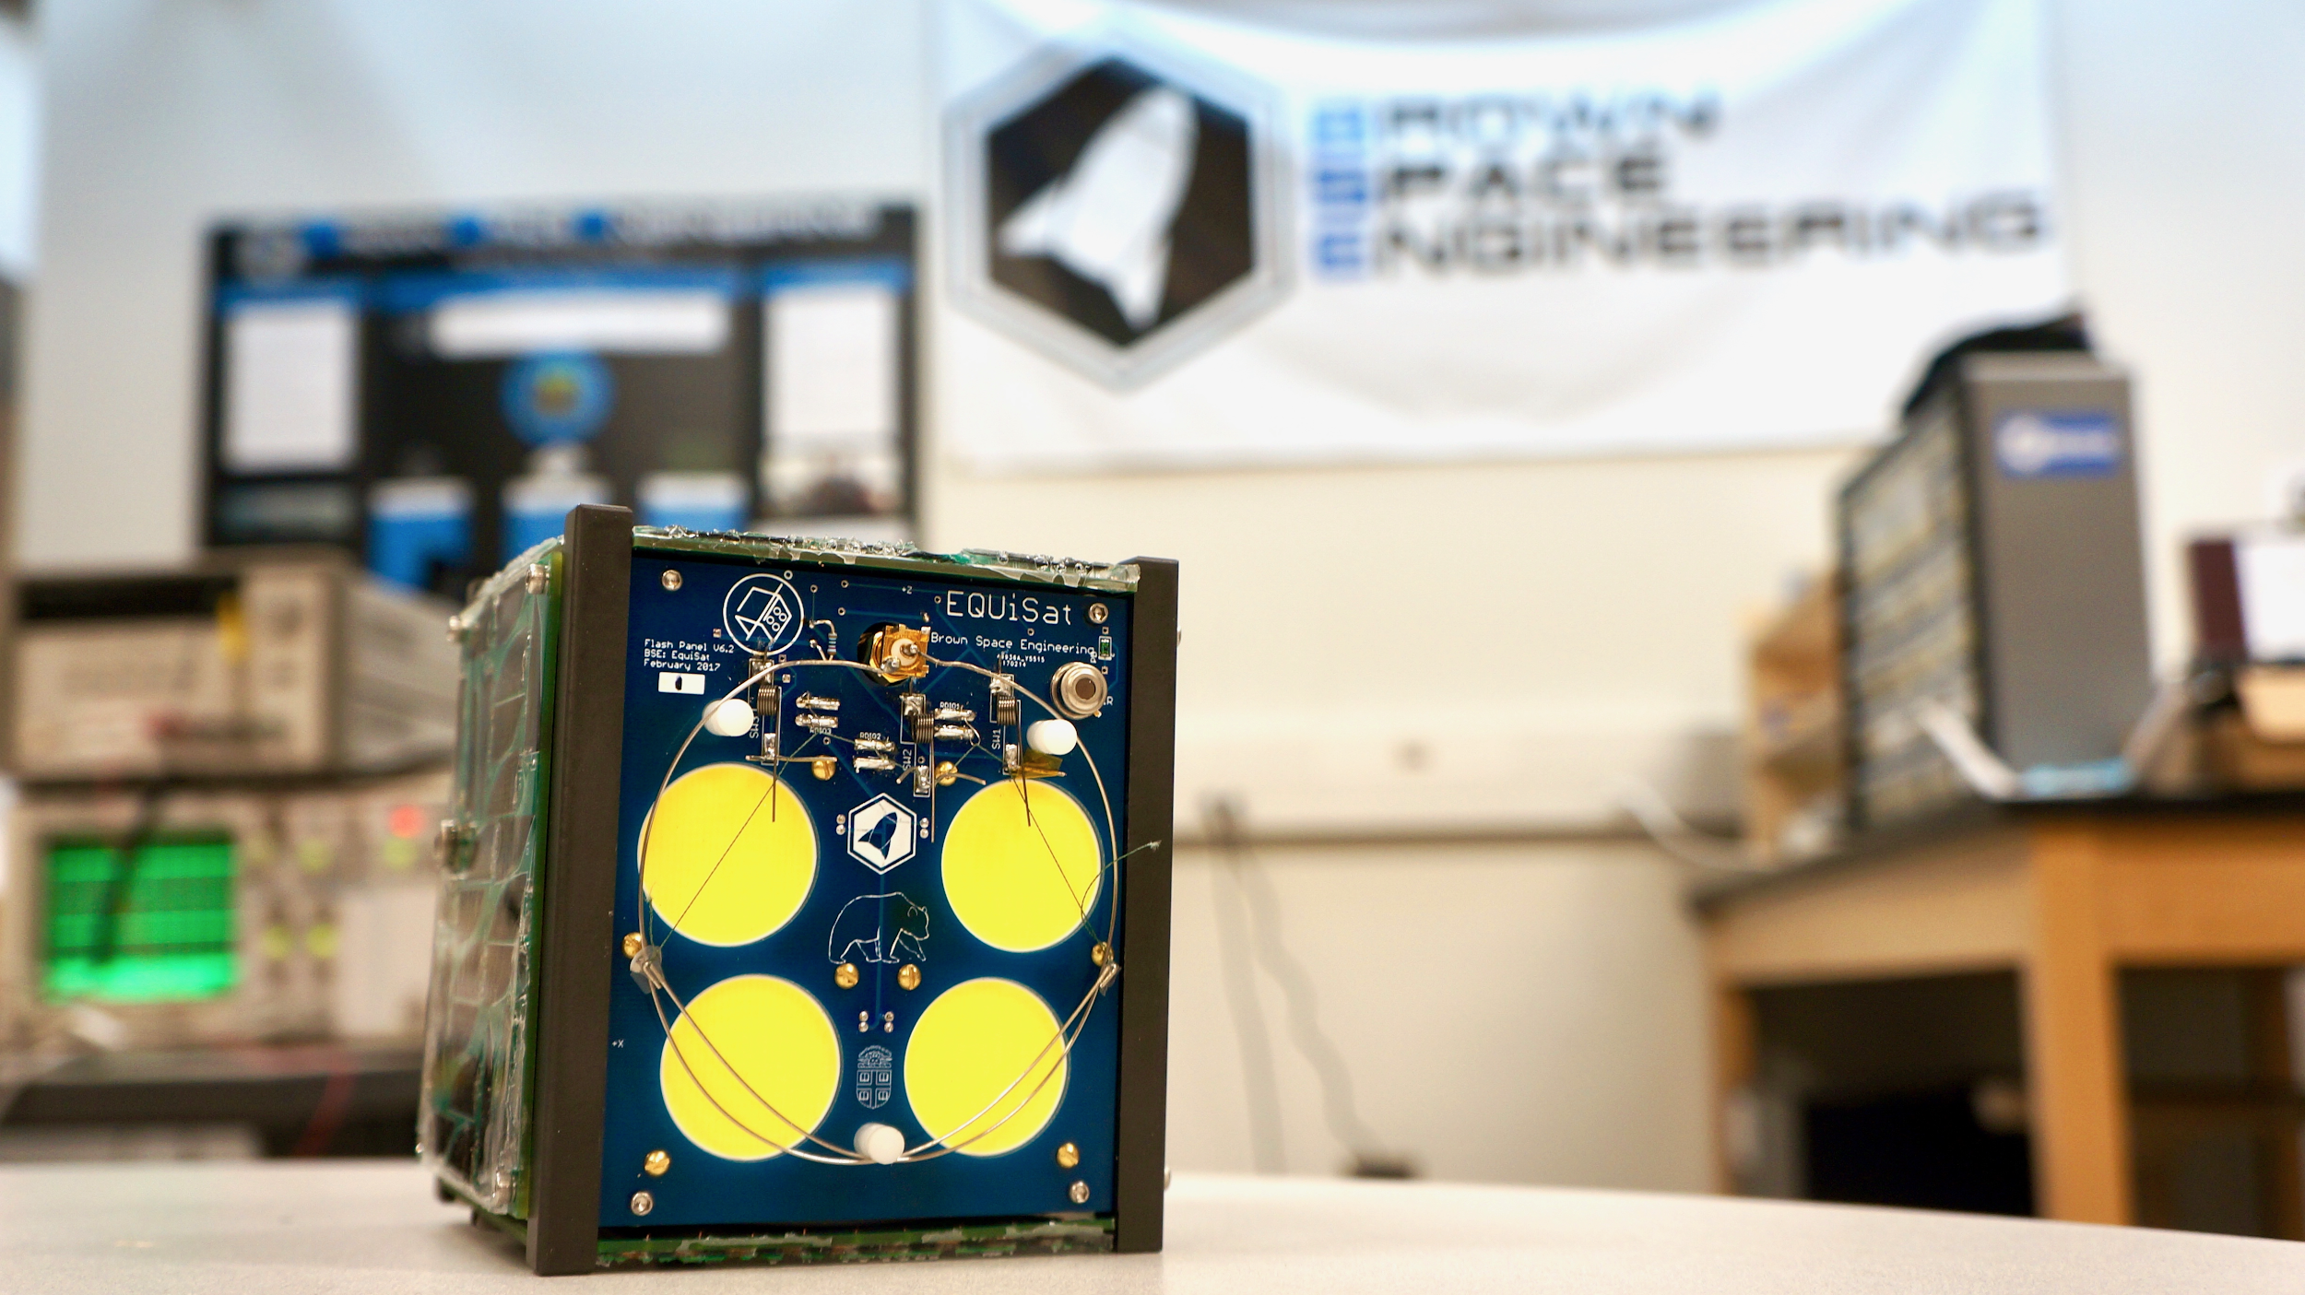



Brown Space Engineering: EquiSat

Last Updated: 2/14/2018

Flight Acceptance Test Requirements for Lithium-ion Cells and Battery Packs

The Following Testing Criterion are taken from the NanoRacks Document NR-SRD-139 Flight Acceptance Test Requirements for Lithium-ion Cells and Battery Packs

# Changelog

|  |  |  |
| --- | --- | --- |
| **Version** | **Date** | **Changes** |
| 1.0 | 2/14/2018 | Initial Version |
| 1.1 | 2/20/2018 | Short-Circuit Protection |
| 1.2 | 3/29/2018 | Corrected battery part numbers and added 14-day OCV test |

# Table of Contents

**Introduction** 3

**Definitions and Acronyms** 3

**Required Test Procedures - Physical and Electrochemical Characteristics**  3-4

i. Test Documentation

ii. Visual Inspection

iii. Measurement of Physical Properties

iv. Electrochemical Characteristics

**Charge Cycling Data Procedures** 5-6

**External Short Protection and Circuit Analysis**  6-7

**Vibration Test Procedure** 8-11

**Vacuum Test Procedure** 11-12

# Conclusion 12

# 1. Introduction

This document describes the tests required for Lithium-Ion cells and battery packs to determine if they are acceptable for flight to the ISS. The requirements stated in this document are based on JSC EP-WI-032 ’*Statement of Work: Engineering Evaluation, Qualification and Flight Acceptance Tests for Lithium-ion Cells and Battery Packs for Small Satellite Systems*.’

# 2. Definitions and Acronyms

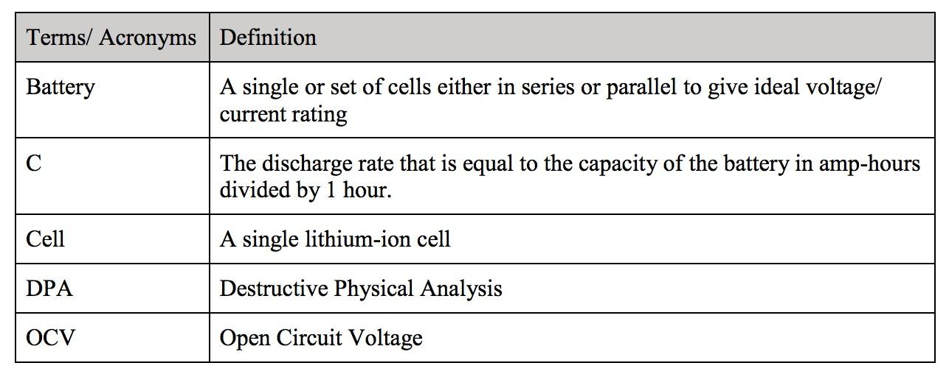

For the procedures outlined in this document, all test values (temperature included) must be recorded for each corresponding cell/ battery pack. Serialize all cells/ batteries before testing. Pictures should be taken throughout the testing process. Cells/ batteries under test should not be left in a discharged state between tests.

# 3. Required Test Procedures - Physical and Electrochemical Characteristics

3.1 Test Documentation

Four Li-Ion batteries (3.7V 2800mAh) are used in EQUISat. They are ICR18650 cells, manufactured by LG Chem. All Li-Ion batteries were manufactured on June 2016. They are phosphate based, and were tested in the fall of 2017. Serial numbers and physical characteristics are shown in Table 1.

Two LiFePO4 (3.3V 1100mAh) batteries are used in EQUISat. They are APR18650 cells, manufactured by A123 Systems. All LiFePO4 cells were manufactured on October 2015. They are phosphate based, and were also tested in the fall of 2017. Serial numbers and physical characteristics are shown in Table 1.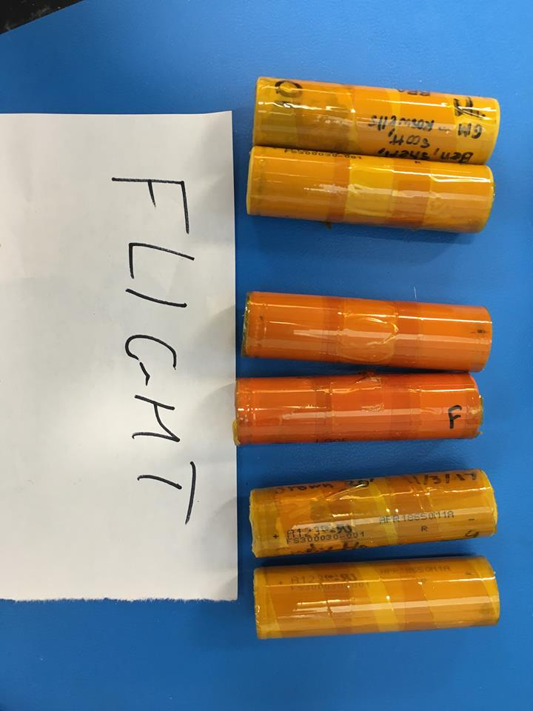

**Figure 1(a).** All 6 flight batteries prior to testing. The four yellow batteries on the exterior are LiFePO4 and the two in the interior are Li-Ion.

3.2 Visual Inspection

**Procedure:** Inspect cells/batteries for any deformations such as scrapes, bulges, or dents. Record all findings. Inspect cells/ batteries for any deformations such as scrapes, bulges, or dents. Record all findings.

Visual inspection of flight batteries showed no significant dents, bruises, or unintended marks. Written marks indicating battery number (9F, 10F, 11F, 12F, T1, T2) are written as identifiers on the LiFePO4 and Li-Ion batteries. Battery serial numbers were printed on the side of the battery by the manufacturer.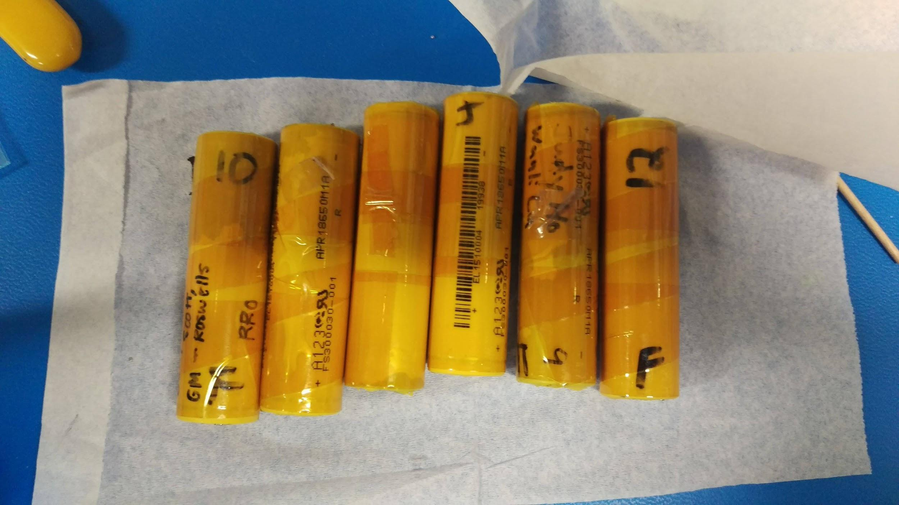

**Figure 1(b):** Six labeled LiFePO4 cells prior to testing. Excess cells were tested to ensure backup in the case of cell failure.

3.3 Measurement of Physical Properties

The physical properties of the batteries, including length, width, height, and mass were measured and recorded. The physical properties of the batteries, for the most part, remained constant throughout testing and across all flight batteries. Overall, there there was less than a 1 percent difference in the measurements across trials.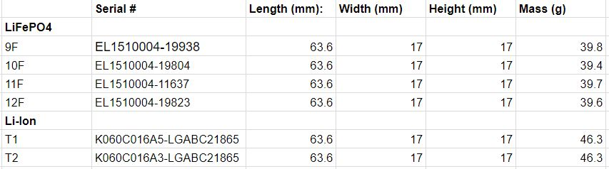

**Table 1:** Physical properties of the batteries before testing.

3.4 Electrochemical Characteristics

3.4 A,B Measurement of Open Circuit Voltage, Measurement of Closed Circuit Voltage

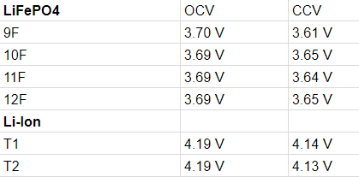

**Table 2:** The electrochemical properties of the batteries prior to testing. CCV was measured by connecting the battery to a programmable load and measuring the circuit current after 30 seconds.

3.4C Open Circuit Voltage (OCV) 14 day test

The LiFePO4 and Li-Ion batteries were discharged to their respective minimum allowable voltages (per their datasheets), 2.5V and 3.0V. The OCVs recorded at discharge termination, as well as after 1, 3, 7, 10, and 14 days are shown below in Table 2B.

|  |  |  |  |  |  |  |  |  |  |  |  |
| --- | --- | --- | --- | --- | --- | --- | --- | --- | --- | --- | --- |
|  | **Serial #** | **L (mm)** | **W (mm)** | **H (mm)** | **M (g)** | **OCV (V)** | **OCV 1 day (V)** | **OCV 3 days (V)** | **OCV 7 days (V)** | **OCV 10 days (V)** | **OCV 14 days (V)** |
| **LiFePO4** |  |  |  |  |  |  |  |  |  |  |  |
| 9F | EL1510004-19938 | 63.6 | 17 | 17 | 39.8 | 3.701 | 3.700 | 3.702 | 3.701 | 3.701 | 3.702 |
| 10F | EL1510004-19804 | 63.6 | 17 | 17 | 39.4 | 3.692 | 3.692 | 3.693 | 3.692 | 3.692 | 3.691 |
| 11F | EL1510004-11637 | 63.6 | 17 | 17 | 39.7 | 3.699 | 3.698 | 3.700 | 3.698 | 3.697 | 3.698 |
| 12F | EL1510004-19823 | 63.6 | 17 | 17 | 39.6 | 3.693 | 3.693 | 3.691 | 3.693 | 3.691 | 3.692 |
| **Li-Ion** |  |  |  |  |  |  |  |  |  |  |  |
| T1 | K060C016A5-LGABC21865 | 63.6 | 17 | 17 | 46.3 | 4.191 | 4.191 | 4.190 | 4.191 | 4.191 | 4.190 |
| T2 | K060C016A3-LGABC21865 | 63.6 | 17 | 17 | 46.3 | 4.191 | 4.191 | 4.192 | 4.191 | 4.191 | 4.192 |

Table 2B: Data for Open Circuit Voltage (OCV) 14 day test performed on EQUiSat’s flight batteries

From the time of discharge termination to the same time 14 days afterwards, no battery showed more than a 2.0mV decline. Therefore, none of the 6 flight batteries were rejected.

# 4. Charge Cycling Data Procedures

**Procedure:** The Charge Cycling Data Procedures include the following cycles in this order: Charge, Discharge, Charge, Discharge, and Charge. Record relevant data for all these cycles. The temperatures for these cycles should also be recorded and a 10 minute rest period should be provided between charge and discharge.

1. Charge the cells/ batteries to 4.2 V using a current of C/2. Then hold the batteries at a constant 4.2 V until the current drops below 50mA.
2. Discharge the battery pack at a rate of C/2 until the voltage drops to 3.0V
3. Repeat charge cycling procedures until cycling is complete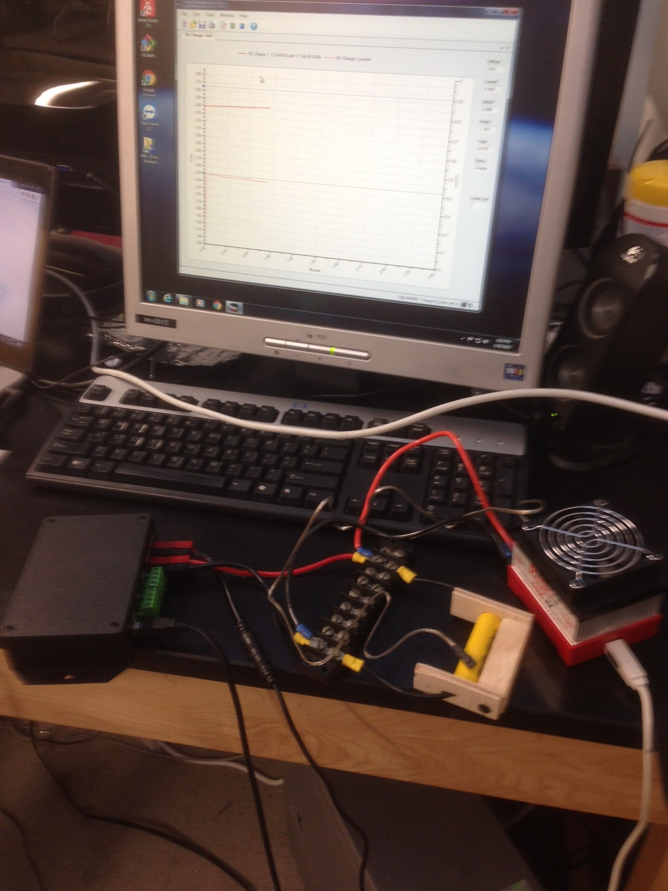

Charge cycling was performed on LiFePO4 and Li-Ion batteries to ascertain power charge and discharge curves. A CBA IV unit by West Mountain Radio was used to charge and discharge the batteries at a constant current, while voltage and temperature were recorded over time. Shown to the right is an image of the experimental setup for a LiFePO4 battery charge-discharge test. The West Mountain Radio voltage tracker software allowed for continuous measurement of the power profile of the batteries during charging.

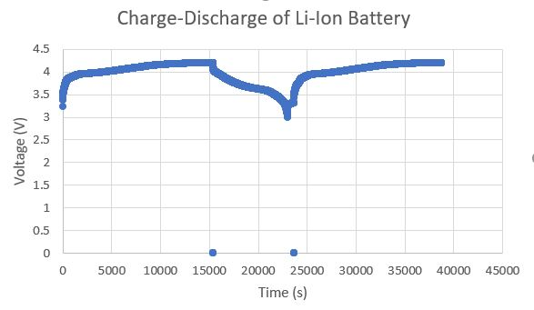

**Figure 2(a):** Charge-Discharge profile of LiFePO4batteries prior to testing

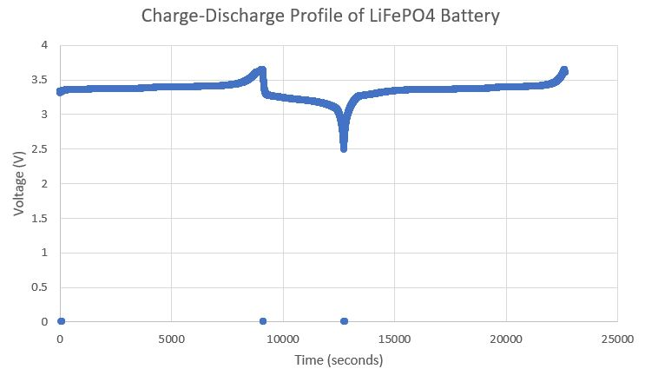

**Figure 2(b):** Charge-Discharge profile of Li-Ion batteries prior to testing

LiFePO4 batteries were charged at 1.1 Ah to a peak voltage of 3.7 V and discharged to a minimum voltage of 2.5 V. Three cycles were performed (charge-discharge-charge). Similarly, Li-Ion batteries batteries were charged to a peak voltage of 4.2 V, and discharged to a minimum of 3.0 V at 2.2 Ah. LiFePO4 charge cycling results yielded a 3624 second, or 1 hour discharge time at 1.1 Ah, at a relatively constant temperature of 20.4 degrees Celsius. Mean charge time was 1.8 hours. Li-ion charge cycling results yielded an 8200 second, or 2.28 hour discharge time at 2.2 Ah, at a constant temperature of 17.5 degrees 20.5 degrees Celsius. Mean charge time was 3.8 hours.

**5 and 6. External Short Protection and Circuit Analysis** The flight protection circuitry was designed to protect the integrity of the cells in the event of an external short circuit. Shown below are diagrams detailing the circuitry of the battery board.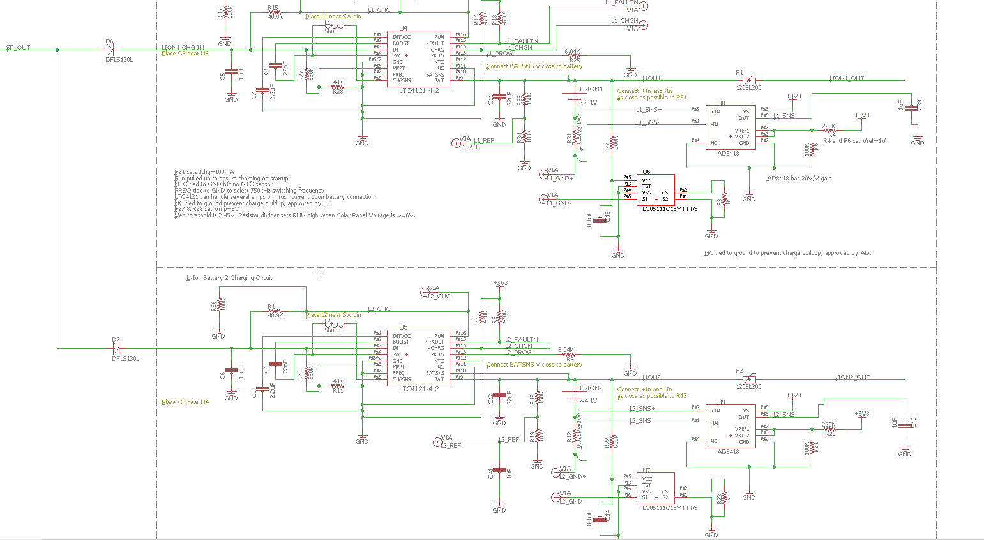

**Figure 3:** Circuit analysis developed through AutoDesk Eagle of EQUISAT’s battery board.

To ensure protection in the case of an external short, Li-Ion batteries were connected to the battery board and then shorted. However, LiFePO4 batteries won’t be continuously powering a load in EQUISat, and only connected when the satellite powers its CXM-27 COB LED array.

**Procedure:** Non-flight Li-ion batteries were connected appropriately to EQUISat’s battery board. While active, the battery board underwent an external short, where cathode and anode leads were connected, completing the short circuit. The purpose of this was to show that the cells are still acceptable for testing because they have retained their capacity within 5% of the previously run cycle and that the circuitry can be expected to function within 100 ms to prevent damaging the batteries.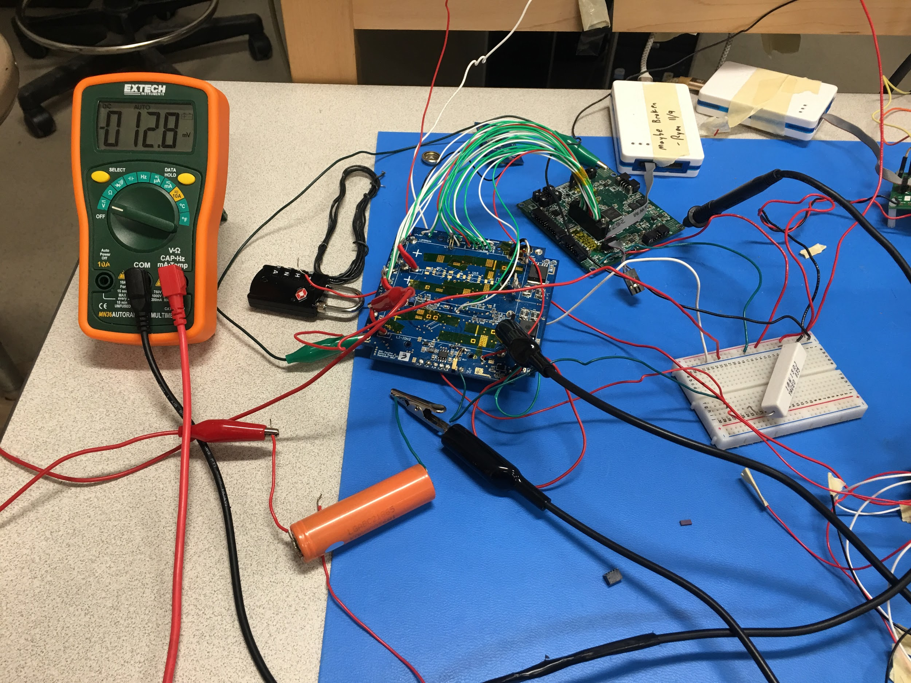

Shown to the left is the test setup for the external short. Li-Ion batteries were connected to the battery board, a multimeter to measure voltage, and an oscilloscope to measure response time. Two runs were conducted, where the battery response time was measured by the oscilloscope. Show below are the results from the test. This yields a response time of 10 ms before the protection chip powers off the circuit, which satisfies the 100 ms time criteria for flight batteries.

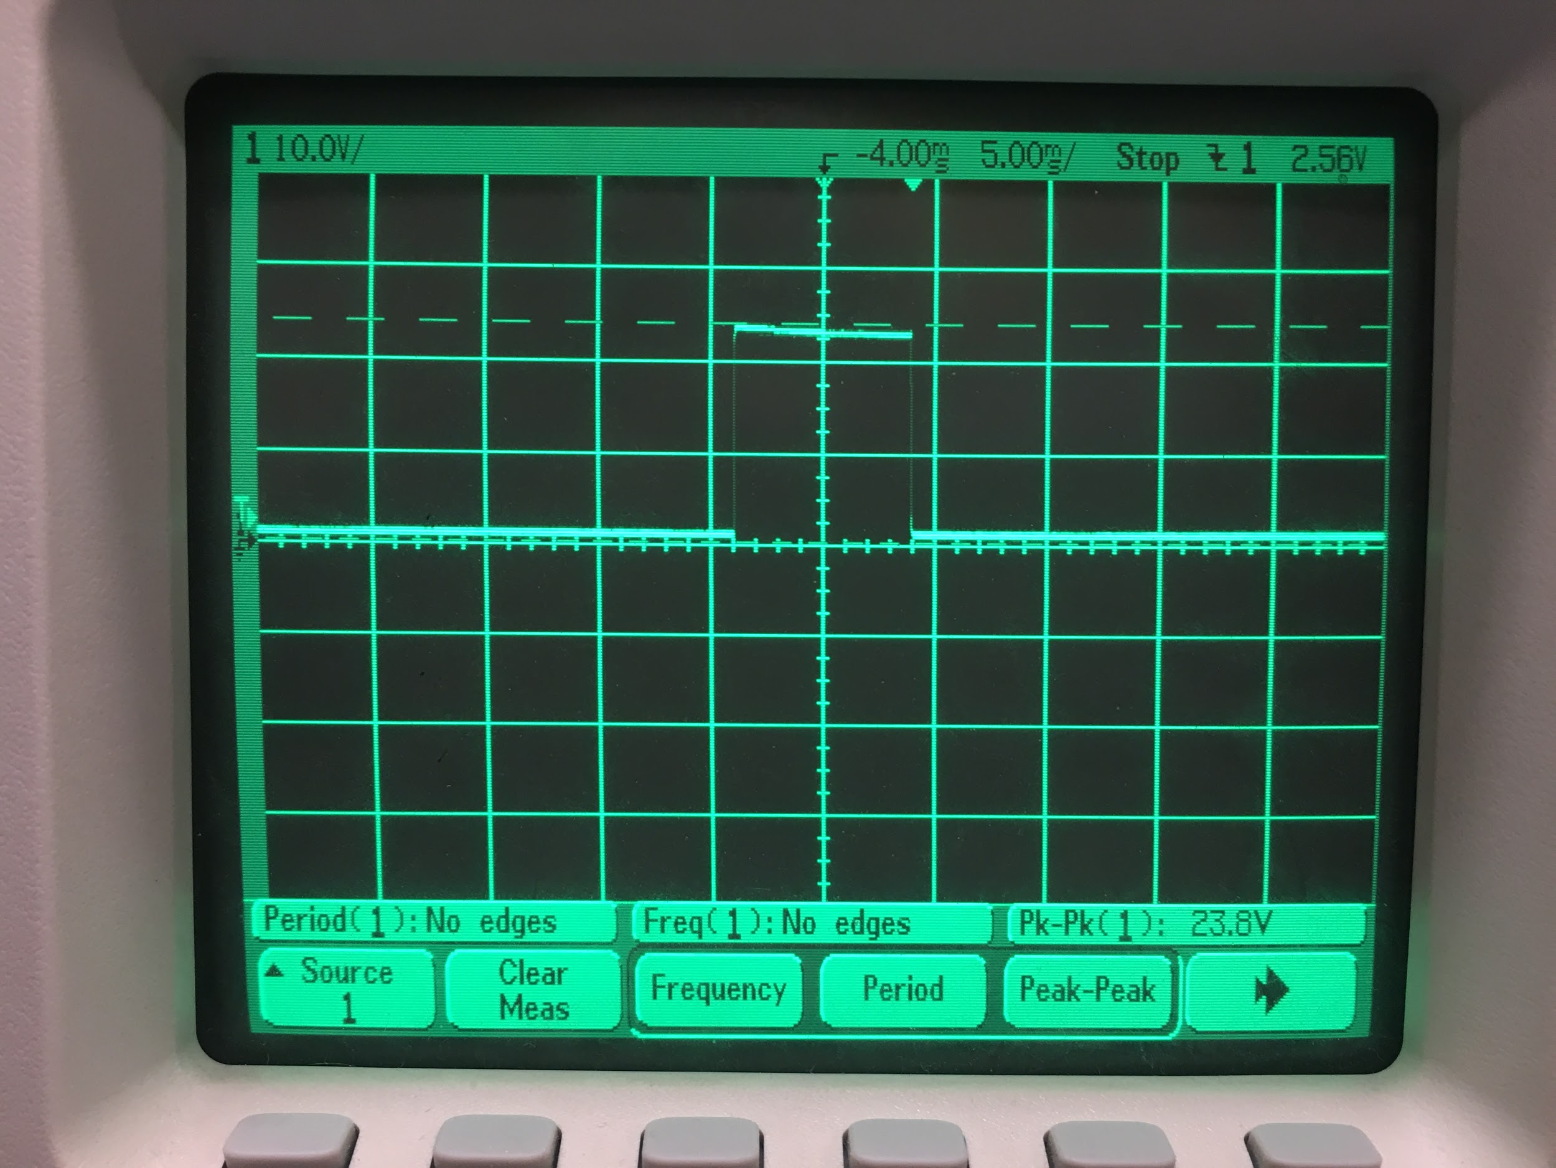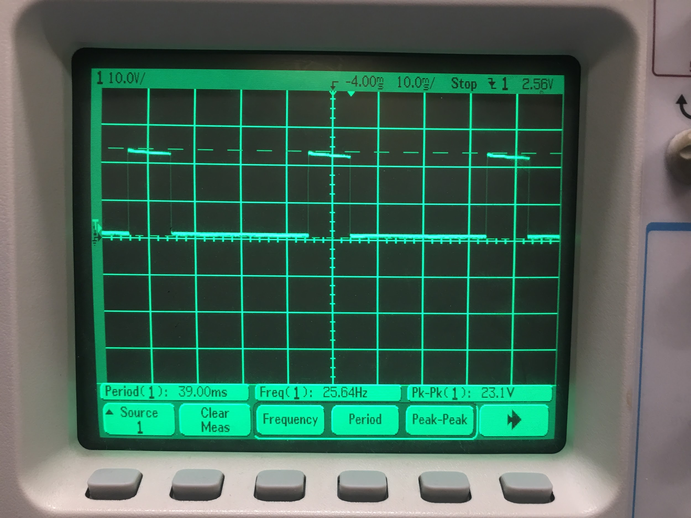

# Figure 3 (a) and (b): Circuitry response time following external short test.

|  |  |
| --- | --- |
| **Voltage Before** | **Voltage After** |
| 4.11 V | 4.11 V |

# Table 3: Li-ion voltage before and after external short test.

# Thus, the test showed that the flight protection circuitry for Li-Ion batteries can be expected to function within 100 ms. For LiFePO4 batteries, built in protection to protect against high amperage does not exist. However, due to the nature of the circuitry, power will not be supplied until directly needed to power the LEDs, and there is minimal risk of an external short.

# 7. Vibration Test Procedure

Record the OCV for each cell/ battery before vibration testing and between each axis of vibration. Vibration testing should follow the spectrum as specified in Table 1 for one minute on each axis

Table 3: OCV of batteries prior to and following axial vibration tests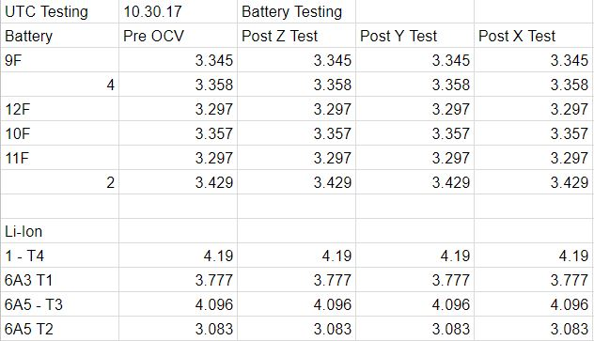

Discharge/ charge/ discharge cycle each battery after the vibration tests and record the capacity. The pass/ fail criteria requires that there shall be less than 0.1 percent change in the OCV and less than 5 percent change in capacity before and after vibration tests and throughout the remainder of the test procedures.

Following vibration testing as outlined in NR-SRD 139, OCV remained constant in both LiFePO4 and Li-Ion batteries, as seen in Table 3. Charge-discharge tests performed on the batteries showed less than 5 percent change in capacity across trials following vacuum testing (Figure 3 and 4). 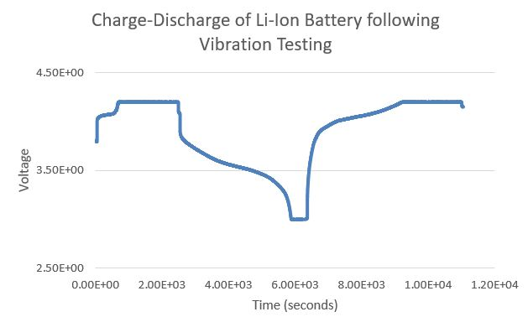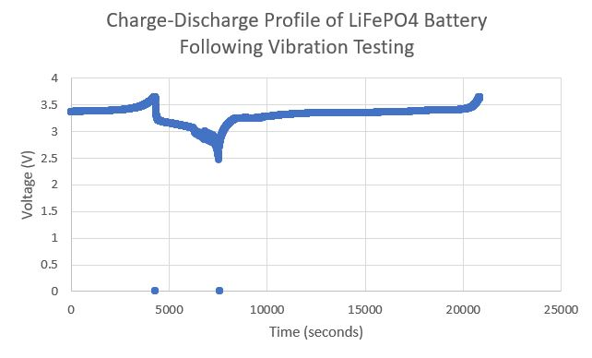

**Figure 4:** Charge-discharge profile of LiFePO4 and Li-Ion batteries following vibration testing.

Figure 4: Charge-discharge profile of Li-Ion batteries prior to vibrational testing

Vibration testing was performed at the United Technology Company. The results of tests for one of three axis is shown below in the y direction in Figure 5.

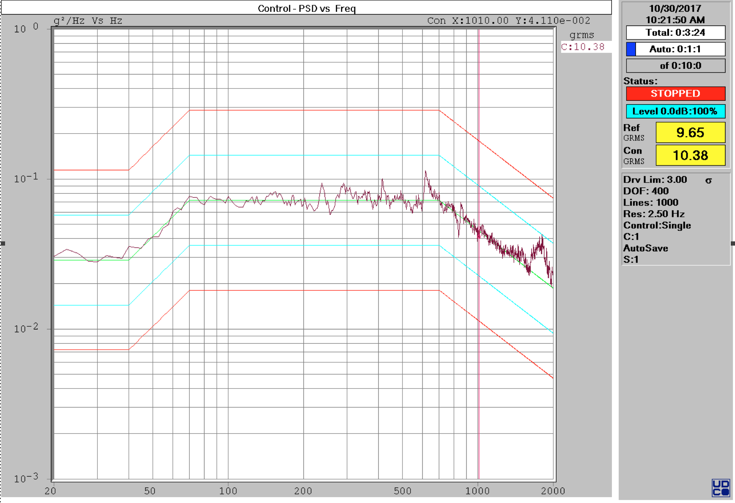

### CONTROL PARAMETERS

CONTROL CHANNEL(S): 1

CONTROL TYPE: SINGLE

FREQUENCY RANGE: 2500 Hz

NUMBER OF PSD LINES: 1000

FREQUENCY RESOLUTION: 2.500 Hz

DOF: 400

SIGMA DRIVE LIMITING: 3.00

### INPUT CHANNEL PARAMETERS

|  |  |  |
| --- | --- | --- |
| **Sensitivity**  **(mV/g)** | **Coupling**  **(AC/DC)** | **Max.Range**  **(g rms)** |
| 10.00 | AC | 10.00 |
| 10.00 | AC | 10.00 |
| 10.00 | AC | 10.00 |
| 10.00 | AC | 10.00 |
| 10.00 | AC | 50.00 |
| 10.00 | AC | 50.00 |
| 10.00 | AC | 50.00 |
| 10.00 | AC | 50.00 |
| 10.00 | AC | 50.00 |
| 10.00 | AC | 50.00 |
| 10.00 | AC | 50.00 |
| 10.00 | AC | 50.00 |
| 10.00 | AC | 50.00 |
| 10.00 | AC | 50.00 |

### REFERENCE BREAK POINT TABLE

|  |  |  |  |  |  |  |  |
| --- | --- | --- | --- | --- | --- | --- | --- |
| **BP**  **#** | **Freq**  **(Hz)** | **Level**  **(g²/Hz)** | **Slope**  **(dB/oct)** | **Alarm-**  **(-dB)** | **Alarm+**  **(+dB)** | **Abort-**  **(-dB)** | **Abort+**  **(+dB)** |
| 1 | 20.00 | 0.0288000 |  | -3.00 | 3.00 | -6.00 | 6.00 |
| 2 | 40.00 | 0.0288000 | 4.913 | -3.00 | 3.00 | -6.00 | 6.00 |
| 3 | 70.00 | 0.0720125 |  | -3.00 | 3.00 | -6.00 | 6.00 |
| 4 | 700.00 | 0.0720123 | -3.850 | -3.00 | 3.00 | -6.00 | 6.00 |
| 5 | 2000.00 | 0.0187195 | -3.850 | -3.00 | 3.00 | -6.00 | 6.00 |

Accel: 9.65 g rms, Est. Vel: 10.03 in/s pk, Est. Disp: 0.09 in pp

### TEST STARTUP & SCHEDULE PARAMETERS

START LEVEL: -12.00 dB, (25.12% of full level)

AUTO RAMP RATE: MEDIUM

AUTO RANGE SETTLE PERIOD: FAST

ACCUMULATE TEST TIME WHENEVER LEVEL = 0 dB

TEST DURATION (HH:MM:SS): 0:10:0

### SHAKER/AMPLIFIER SYSTEM SPECS

MAXIMUM RANDOM ACCELERATION: 100.00 g rms

MAXIMUM VELOCITY: 70.00 in/s pk

MAXIMUM DISPLACEMENT: 2000.00 mil pp

MAXIMUM RANDOM PERFORMANCE INPUT VOLTAGE: 2.50 vrms

DRIVE SCALING ADJUSTMENT: 1.00

ARMATURE WEIGHT: 100.00 lbs, LOAD WEIGHT: 170.00 lbs

# 10. Vacuum Test Procedure

**Procedure:**

1. The length, width, and height need to be measured before beginning this test. Length, width, and height are specified in Section 3.2-a. Measurements should be recorded with 0.1mm precision.
2. Obtain and record the mass of each cell/ battery. Measurements should be recorded with 0.1g precision.
3. Measure the voltage of all cells/ batteries and record the values. If any batteries are not fully charged, charge before continuing.
4. Place fully charged batteries into the vacuum chamber at atmospheric pressure and pull vacuum at approximately 8 psi/minute. Maintain vacuum (approximately 0.1 psia) for 6 hours. Re-pressurize the chamber to ambient at a rate of 9 psi/minute.
5. Visually inspect the batteries for leaks, deformations, or bulges. Record any findings.

Obtain measurements of the length, width, and height of the post-vacuum tested batteries.

Obtain and record the mass of each cell/ battery. The pass/ fail criteria requires there to be less than 0.1 percent change in mass. Discharge/ charge/ discharge cycle the cells/ batteries and record the capacity. The pass/ fail criteria requires that there shall be less than 0.1 percent change in the OCV and less than 5 percent change in the capacity before and after vacuum testing.

Table 4: Mass, OCV and length of LiFePO4 and Li-Ion batteries prior to and following vacuum testing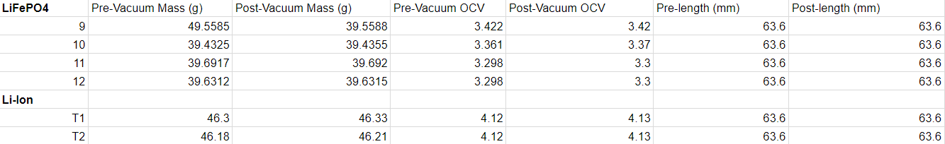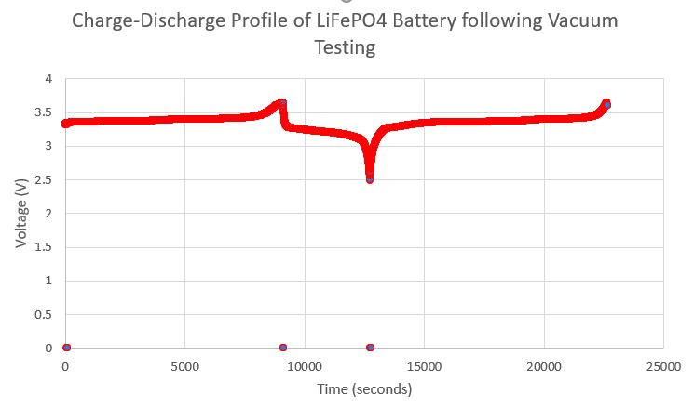

Figure 7: Charge-discharge profile of Li-Ion batteries following vacuum testing

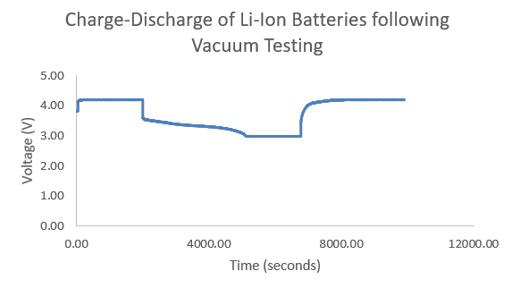

Figure 8: Charge-discharge profile of LiFePO4 batteries following vacuum testing

From the above data, no significant (> 0.1%) changes in OCV, mass, or length were observed in flight batteries following vacuum testing. Capacities of LiFePO4 and Li-Ion batteries remained consistent from prior charge cycling tests and observed charge cycling following vibration testing.

**Conclusion**

LiFePO4 and Li-Ion batteries passed charge cycling data procedures, external short protection, vibration tests, and vacuum tests, maintaining constant physical characteristics, and a steady OCV, CCV, and charge cycle following physical tests.